**What?**

**Reviews are feelings expressed by customers about a product or service they paid for. It is a rich source of quickly validating how well a business interfaces with their customers so that they can know where to make amends or make improvements. Reviews can come in form of written expression or ratings on a given scale, or both.**

Generally, online reviews are:

1. Biggest source of social proof: We’re more likely to make a purchase if others around us—even total strangers—agree that it is a good decision. Today, [online reviews](https://mention.com/blog/online-reputation-management-tools) are the biggest source of social proof, and they have a clear impact on sales.
2. Make a business More Visible: Being a successful brand also means you’re a visible one.

Most shoppers will look on search engines like Google and Bing, or even on Facebook, when deciding what to buy. These websites all have their own unique ways of indexing and surfacing content, but they all value original and fresh content, and customer reviews can definitely help feed the content machine, keeping your brand favoured by these algorithms.

1. Make a business Look Trustworthy: Your brand can build significant trust and credibility from a steady stream of positive reviews.
2. Expand the Conversation about a business: Very good (or bad) reviews have a way of quickly spreading.

**Why should I care?**

* Not all business establishments can enlist the services of data analysts or Data scientists so that they can carry out sentiment or predictive analysis on customer feedback, therefore, it is very important that every business know where their major customer base are more likely to drop reviews and ratings and treat each case (especially the negative comments) by its merit

**How do consumers find and leverage online reviews?**

**Yelp:**

* As one of the most popular online review sites, Yelp has the power to make or break a business. Attention from Yelp reviewers doesn’t always translate into a positive for a business
* One problem is that Yelp’s algorithm displays its bad reviews and filters its good ones. This means that if a business has seven good reviews and two bad ones, a visitor to their Yelp page will not immediately see all the good reviews that balance the poor ones
* Some business owners feel ambushed by what they feel are inaccurate and outright false customer reviews that they cannot get removed
* There is the belief that businesses do offer pay for fake reviews

**Google:**

Google first began showing review stars with a localized search at the end of 2010. At that time, it was aggregating reviews from other sites:

::: Picture 1

In a span of a few short years, it has leaped over Yelp, acquired Zagat, and shifted its focus from aggregating reviews to hosting its own. That shift has paid off tremendously, and affected the entire online review ecosystem.

:::Picture2

According to ReviewTrackers’ data, 63.6 percent of consumers say they are likely to check reviews on Google before visiting a business — more than any other review site.

Google has quickly become the major force in online reviews, while Yelp is now ranked second at 45.18 percent, followed by TripAdvisor and Facebook.

What’s interesting about Google reviews — and what makes them different — is that Google search algorithm predicts you’re looking for something nearby and shows you businesses and locations in your vicinity. This accounts for a third of all searches. Most website traffic comes through Google, therefore, Google effectively pre-empts other review sites by showing its own star ratings to users before they can click through to their search result. This means that Google has effectively cut in line, jumping ahead of the major players in the review industry.

The takeaway for businesses is clear: almost two-thirds of consumers are saying they’re most likely to check Google reviews, so make sure you’ve claimed your Google My Business listing and are actively watching those reviews for every location of your business.

**Traditional Non-review sites coming out strong**

* Consumers are more likely to look on to Google when searching for goods/services but most importantly, they are more likely to leave reviews on Google
* Over half of a business location’s reviews were on Google and Facebook in 2017 and this keeps growing
* In the span of a few years, reviews have found a bigger home on Facebook and Google than they had on review-only sites like Yelp or TripAdvisor. This implies that consumers could hardly do any research about a brand before immediately running into reviews about the brand. This increases a consumer’s access to reviews.
* From consumer’s perspective, almost everyone has a Facebook or Google account and is always logged into these accounts. There’s almost no friction when a user wants to leave a review because they don’t have to log in to a different website or take any other steps. They’re always plugged into Google or Facebook. This means more reviews on these platforms.
* From business perspective, the same holds true. Almost every business has a **Google My Business account** —and almost every business has a Facebook Page or Facebook Business Manager Account. With both businesses and consumers constantly engaged with Google and Facebook, it only makes sense that these platforms become the dominant platforms for customer reviews.

**How do reviews and ratings impact consumers’ behaviour?**

* Negative reviews drive away customers
* negative reviews have convinced 94 percent of consumers to avoid a business
* 86% of people will hesitate to purchase from a business that has negative online reviews.
* On average, a one-star increase on Yelp leads to a 5 to 9% increase in a business’s revenue.
* A single negative review can cost a business about 30 customers
* A five star rating and garnished reviews don’t usually earn customers’ trust
* 88% of customers trust online reviews
* 72% say that positive reviews make them trust a local business more
* 92% of users will use a local business if it has at least a 4-star rating
* 72% of consumers will take action only after reading a positive review

**Current trends**

* Reviews are getting shorter: with more and more growth in mobile traffic and more and more reviews appearing on Google and social media, reviews are no longer dropped like mini-essays, their lengths are almost the length of a tweet, more direct and straight to the point
* More positive: Since people are mostly logged in on Facebook and Google, it has become much easier to leave a positive review after a positive experience from a business; they do this without the need to log in to a separate website. Going to separate website to drop a review can happen when a user has really been fired up by a bad experience. This has led to a lot of more negative than positive reviews in the past
* More people leave reviews: With people always on these platforms, more people are now leaving reviews
* Google is where the most positive reviews occur
* Every business should care about reviews and handle issues head-on

**Responding to negative reviews as a business**

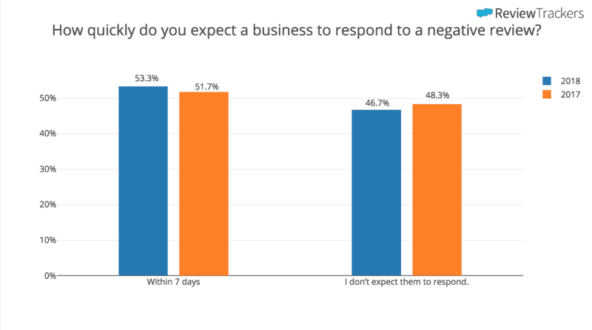

More customers expect businesses to respond to their reviews — and quickly

According to graph above, 53.3 percent of customers expect businesses to respond to their online review within 7 days. This marks an increase from 51.7 percent in 2017.

More than half of consumers expect a response from a business and that makes sense as the popularity of review sites is driven by customers’ genuine desire to engage with businesses.

In these digital spaces — just as in traditional feedback channels like post-transaction surveys and support and service phone calls — customers want to be heard individually and addressed personally when they’re dissatisfied.

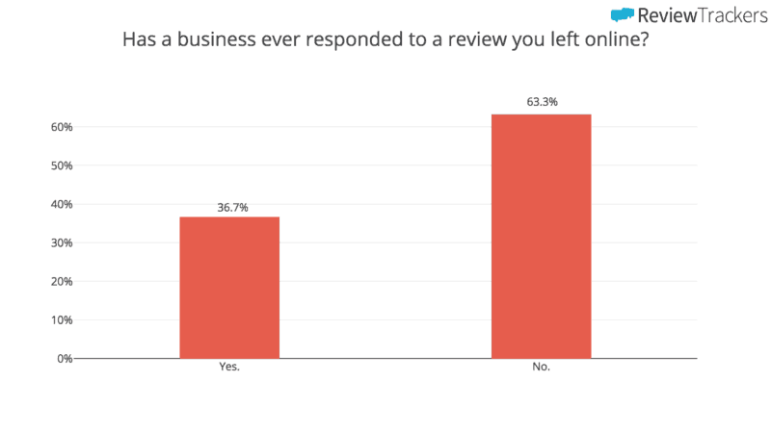

So consumers want to interact with brands when they leave a review. Therefore, it is very important for brands to track and respond to reviews especially the negative ones, but from findings, 63.3 percent of consumers have never heard back from a business after leaving a review. This is a business killer.

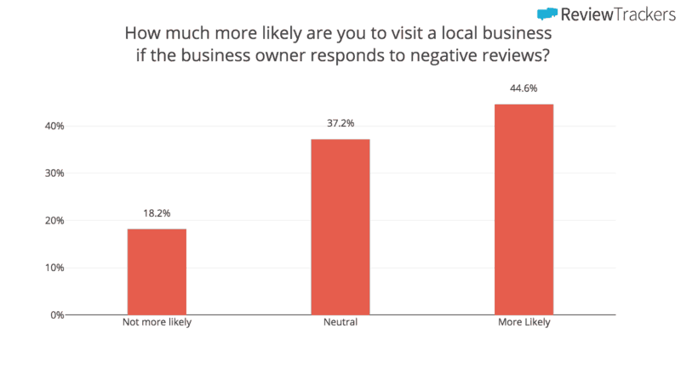

But the takeaway from this is that review responses make a real and measurable difference — not just to the consumer who leaves the review, but to everyone else who visits the business’s review page. Just as shown above, almost 45% of consumers agree that they’re more likely to visit a business if it responds to and addresses issues raised by negative reviews.

Therefore, it is important to:

* Respond promptly
* Be real, admit mistakes, and Correct inaccuracies
* Respond with empathy
* Take it offline if necessary and Provide restitution if it’s warranted
* Highlight your strengths
* Ask loyal customers to share their experiences
* Be consistent in doing this